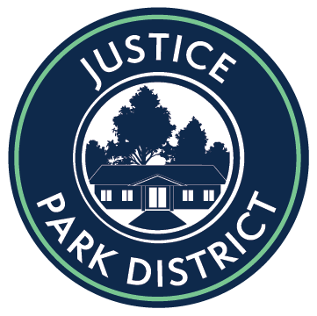

Justice Park District
Board of Commissioners
Regular Board Meeting
February 28, 2022 @ 6:00pm
7747 S. Oak Grove Avenue Justice, IL 60458
Commissioners
Carrie Bernardoni, Larry Noyes, Mark Leahy, Tabatha Sutera, Tom Bosworth
Meeting Minutes

- Call to Order
- Pledge of Allegiance

- Roll Call: Bernardoni, Bosworth, Noyes, Leahy and Sutera

- Public Comment - Barb Stimatz – Concerns about the lights – On February 24,2022 there was a car that was parked in the parking lot. She called the Police they came, and the car left. The lights are on her property. Wanted to know if we spoke after she voiced her concern on 12-17-2021. Commissioner Bernardoni said she will set up a meeting and discuss this.

- Secretary’s Report
- Corrections/Additions/Approval of Agenda
MOTION: Sutera
SECOND: Noyes
VOTE: 5/0 Approval

- Approval of Minutes of Board Meeting 1-24-2022
MOTION: Noyes
SECOND: Sutera
VOTE: 5/0 Approval

- Treasurer’s Report
- Approval of Warrant List - $31,978.57
MOTION: Sutera
SECOND: Bosworth
VOTE: 5/0 Approval

- Approval of Payroll 1-28-2022 – $3,853.60
MOTION: Noyes
SECOND: Sutera
VOTE: 5/0 Approval

- Approval of Payroll 2-11-2022 – $3,840.30
MOTION: Bosworth
SECOND: Noyes
VOTE: 5/0 Approval

- Approval of Payroll 2-25-2022 - $3,974.44
MOTION: Noyes
SECOND: Bosworth
VOTE: 5/0 Approval

- Financial Report given by WRDR – Mary was unable to make the meeting will be at March’s meeting.

- Executive Director’s Report:
All programs will now require at least 6 patrons. Instructors are paid 60-70% of the overall profit. When 2-3 patrons register there is no room to turn a profit. When a new program is introduced, we will give them a 6-week trial period so we will have more time to promote/expand the program. In the event a program does not meet the requirements the program will be cancelled due to low enrollment. We will be seeking volunteers to help with events to cut our cost down.
Our playground equipment was delivered February 23, 2022, and we are looking at the installation to begin late Spring/early Summer of 2022.
Will be applying open lands grant – with intentions to plant more trees around Commissioner Park. Great way to promote earth day and have the community involved. Tentatively Spring of 2023. No plans as of now for Earth Day – something with the community garden.

- New Business

- Discussion/review of the Ordinance No. 2022-03-28-01 in its tentative form

- Approval to set a Public Hearing on the 2022 tentative budget for March 28, 2022, at 6:00pm.
MOTION: Noyes
SECOND: Sutera
VOTE: 5/0 Approval

- Approval of meeting dates for 2022
MOTION: Noyes
SECOND: Bosworth
VOTE: 5/0 Approval

- Adjournment 6:08 pm
MOTION: Sutera
SECOND: Noyes
VOTE: 5/0 Approval

